Analysing Housing Prices in Metropolitan Areas of India

INTRODUCTION :

The housing market in metropolitan areas of India has always been a subject of intense scrutiny and interest, driven by the ever-increasing urbanization and the diverse factors that influence property prices. Understanding and analyzing these housing prices is crucial not only for potential homebuyers and real estate investors but also for policymakers, urban planners, and economists.

Metropolitan areas in India, such as Mumbai, Delhi-NCR, Bangalore, Chennai, and Kolkata, are among the most populous and economically vibrant regions in the country. These cities attract a steady influx of people seeking better job opportunities and improved living standards. As a result, the demand for housing in these metropolitan areas remains consistently high, making them dynamic and competitive real estate markets.

* 1. OVERVIEW :
* Data Collection
* Data Preprocessing
* Feature Engineering
* Exploratory Data Analysis (EDA)
* Market Trends
  1. PURPOSE :

The purpose of analyzing housing prices in metropolitan areas of India is to gain a comprehensive understanding of the factors that influence the cost of real estate in these densely populated urban centers. This analysis can serve multiple objectives:

2. PROBLEM STATEMENT & DESIGN THINKING :

Analyzing housing prices in metropolitan areas of India can be challenging due to several problems and complexities. These issues make it essential to approach the analysis with a nuanced understanding of the Indian real estate market. Here are some of the key problems associated with analyzing housing prices in metropolitan areas of India

2.1 EMPATHY MAP :

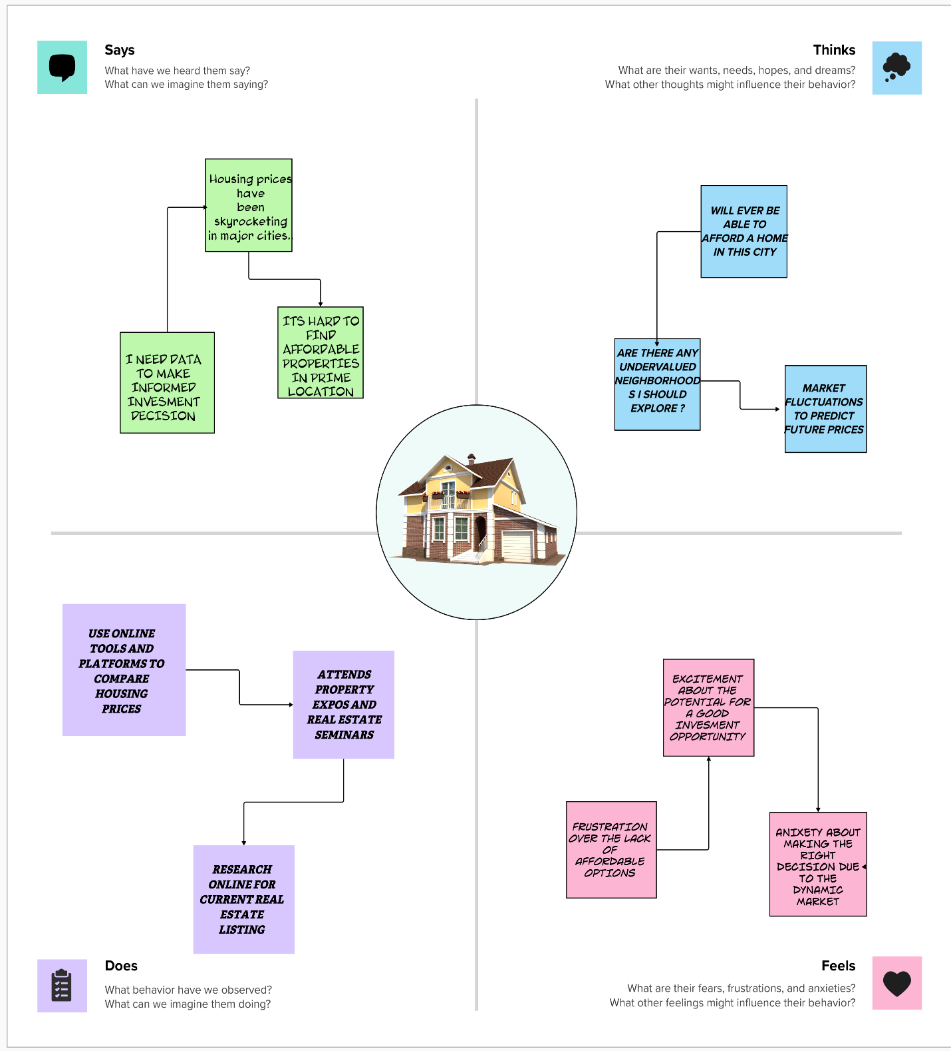

2.2 BRAIN STORMING MAP :



3. RESULTS :

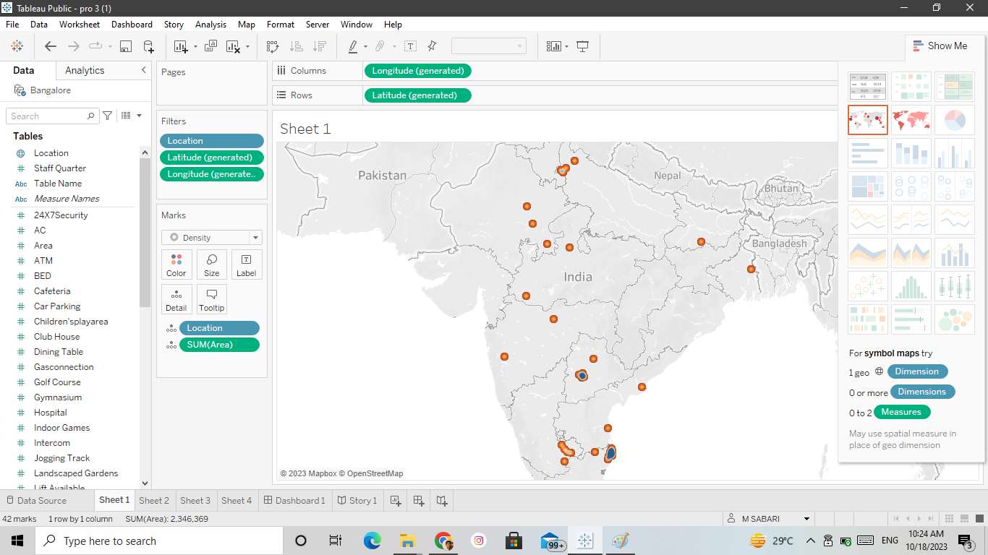

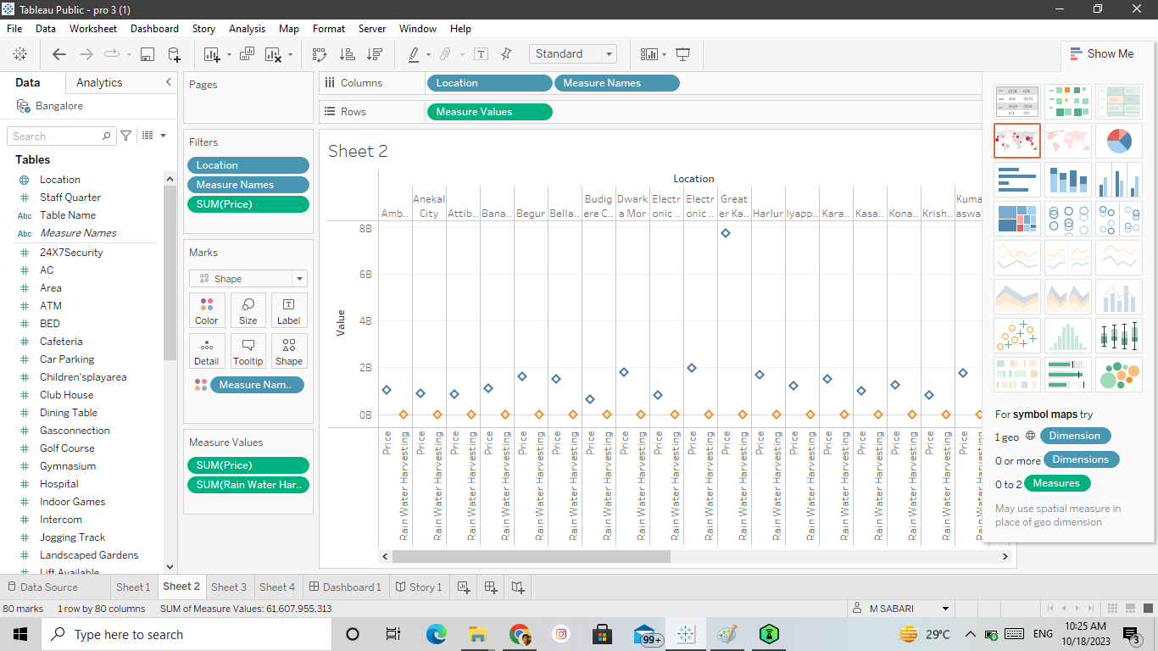

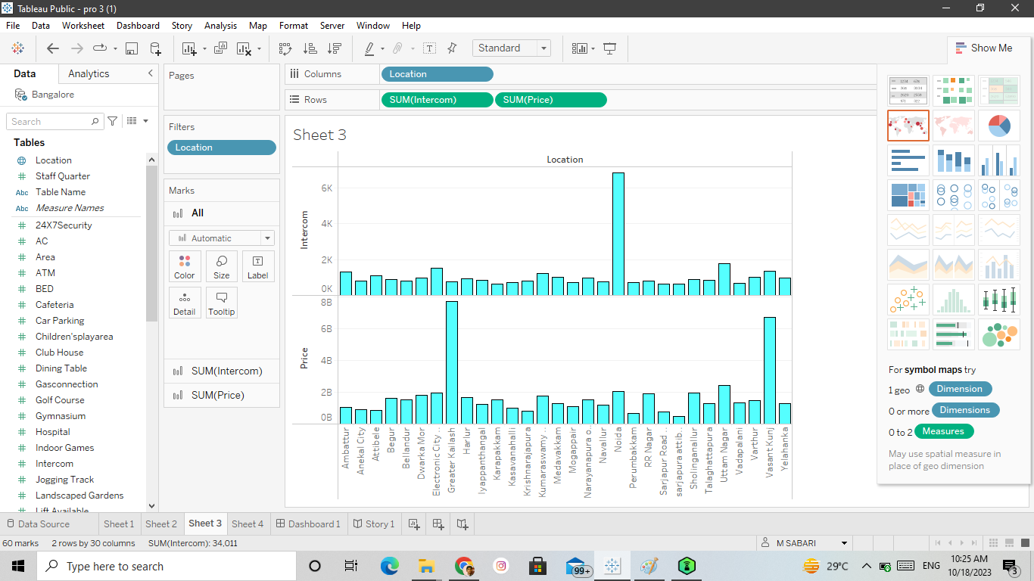

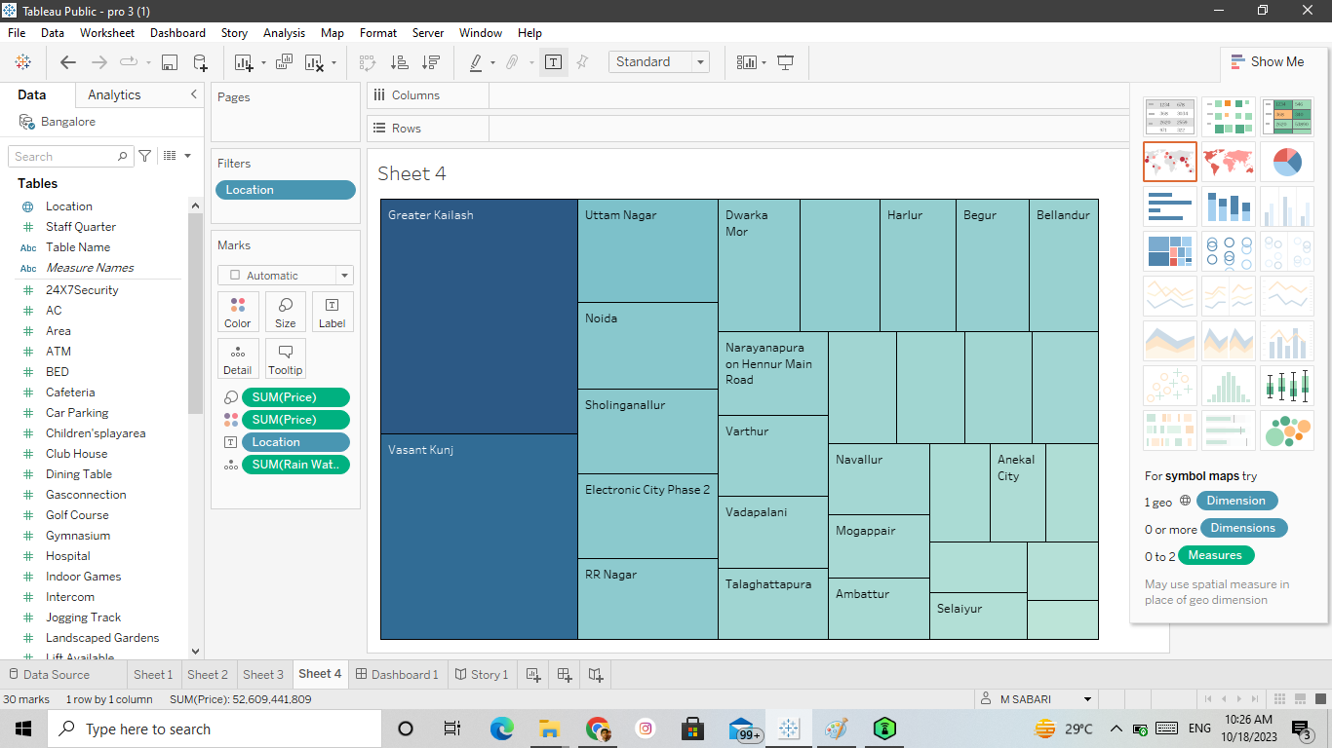

DASH BOARD :

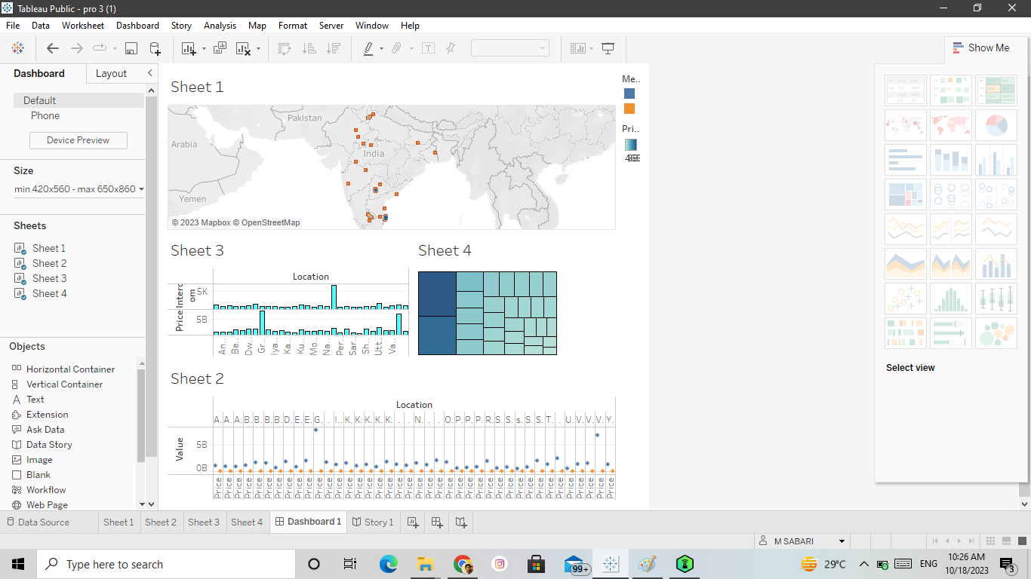

STORY :

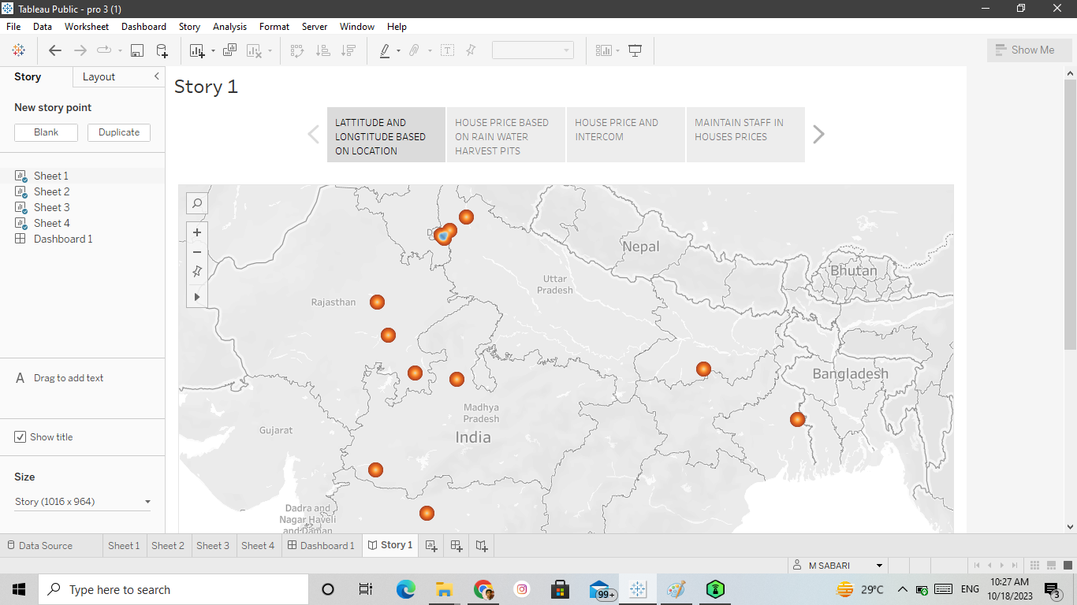

4.ADVANTAGE AND DISADVANTAGE:

ADVANTAGE :

Analyzing housing prices in metropolitan areas of India can provide several advantages for various stakeholders, including homebuyers, real estate developers, investors, and government authorities. Here are some of the key advantages:

Informed Decision-Making for Homebuyers:

a. Price Transparency: It helps prospective homebuyers understand the prevailing market rates, enabling them to make informed decisions.

b. Budget Planning: Buyers can assess whether a particular location or property aligns with their budget and financial goals.

Real Estate Investment Opportunities:

a. Investment Decisions: Investors can identify areas with potential for high returns and make strategic real estate investments.

b. Diversification: Real estate investments can diversify a portfolio, reducing risk compared to traditional asset classes.

Market Trends and Forecasting:

a. Predicting Trends: Analyzing housing prices can help forecast market trends, allowing developers and investors to adapt to changing conditions.

b. Risk Mitigation: Developers can assess the feasibility of their projects and make risk-mitigating decisions.

DISADVANTAGE :

Analyzing housing prices in metropolitan areas of India can be a complex and challenging task, and there are several disadvantages associated with this process. Here are some of the key disadvantages:

Data Quality Issues: In India, data related to housing prices can be inconsistent and unreliable. Many property transactions go unrecorded, and there is a significant amount of black money involved in real estate transactions. This makes it difficult to obtain accurate and up-to-date data for analysis.

Rapidly Changing Market: Metropolitan housing markets in India can be extremely dynamic, with prices fluctuating rapidly. Economic, political, and social factors can impact property values, making it challenging to make long-term predictions or investment decisions.

Lack of Transparency: Real estate transactions in India often lack transparency. Property prices might not reflect the actual market conditions, and there can be hidden costs or undisclosed information about the property that could affect its value.

Regional Variations: India is a diverse country with significant regional variations in housing markets. What holds true for one metropolitan area might not be applicable to another. Analyzing housing prices in a diverse country like India requires a deep

5. APPLICATION:

Analyzing housing prices in metropolitan areas of India can provide valuable insights for a variety of purposes, including real estate investment, urban planning, policy development, and economic research. Here are some potential applications for analyzing housing prices in metropolitan areas of India:

Real Estate Investment:Investors can use housing price data to identify emerging real estate markets and make informed decisions about where to buy or sell properties.

Market Research:Real estate developers and companies can use housing price data to understand market trends, demand-supply dynamics, and consumer preferences.

6. CONCLUSION:

To provide a comprehensive conclusion for an analysis of housing prices in metropolitan areas of India, you would need to summarize the key findings and insights gained from your analysis. Since I don't have access to the specific data or analysis you conducted, I can offer a generic template for your conclusion.

After a detailed analysis of housing prices in metropolitan areas of India, several important insights have been uncovered:

7. FUTURE SCOPE:

Analyzing housing prices in metropolitan areas of India is a crucial field of study with significant future scope. As India continues to urbanize and the population in metropolitan areas grows, the housing market becomes increasingly important. Here are some future prospects and opportunities for analyzing housing prices in Indian metropolitan areas:

As more people look to invest in real estate, especially in metropolitan areas, the need for accurate housing price analysis becomes vital. Investors, both domestic and international, rely on this data to make informed decisions. The future will likely see an increased demand for real estate data and analytics

Metropolitan areas face numerous urban development challenges, and understanding housing price trends is critical for urban planners. This information can help in creating sustainable, affordable, and accessible housing solutions in these cities.

Government policies play a significant role in the housing market. Analyzing housing prices can aid policymakers in crafting effective regulations, tax policies, and subsidies to control property speculation and ensure affordable housing for all income groups.

THANK YOU!